Executive Summary
Process Engineering recommends implementing a standardized allocation planning system across IXD sites to reduce Gen 4.3 Ops Defect % from 39.5% to match Gen 4.2's 28.6% performance. This system will include pre-designated overflow locations and data-driven decision matrices for arc splitting versus headcount reallocation.

Allocation planning currently varies between Central Flow and on-site teams, creating inconsistent processes across locations. This lack of standardization manifests in performance gaps, with Gen 4.3 IXDs showing 39.5% Ops Defect % during Weeks 9-12, compared to 28.6% in Gen 4.2 IXDs. Daily operations regularly deviate from plans due to door closures and MHE issues, requiring on-site Flow teams to make ad-hoc arc splitting decisions. Additionally, misaligned communication between Outbound and Flow teams creates uncertainty about when to split arcs versus reallocate headcount.

To close this performance gap, we will create a standardized allocation planning playbook that defines overflow locations based on volume projections. This playbook will establish clear overflow thresholds to trigger specific actions, removing guesswork from arc splitting and headcount reallocation decisions. Implementation of these standards will begin in Q2 2024, with full deployment across all Gen 4.3 sites by Q3 2024.

Recirc Response SOP
Currently in Policy, there is a posted matrix for situations that can be diagnosed by Flow teams and recommended actions to be taken (Appendix B). Within this matrix, the thresholds for action are not apparent, and the expected time to resolution ranges from 30 minutes to 1.5 hours. An updated algorithm for reacting to recirc will be rolled out as a part of this pilot, which will be focused on at least one SME continuously monitoring carrier utilization, staffing, and induction rates to optimize for TO efficiency. This will be facilitated through the use of the Lane Availability Tool, a script leverages DockFlow to determine when the current allocations exceed the capacity of any MHE.

Overflow Lane Planning
In present state, there is no specific direction given where to split arcs when it is the right decision to do so. At best, arcs are split relatively evenly on RWC and MP with minimal overlap, but there is a disconnect between where Flow teams split freight to be palletized and which doors those pallets will ultimately be transported to. In addition to the allocation plan managed by central flow, overflow lanes will be planned based on MHE capacity and locality to dock doors, with the goals of minimizing both recirc and transportation cost for EOL.

Standardized Allocations Pilot
Pilot Overview
The PE team and Central Flow team conducted a pilot at RDU2 to analyze the operational impacts of designated overflow lanes and data-driven decision making for arc splitting. Both teams theorized that the site would see a decrease in Ops Recirc %, an increase in TP CPLH, an increase in PID Carton Volume, and an increase in fill rate.

Pilot Results
The pilot was conducted in Weeks 10 and 11. Compared to the Weeks 6 through 9, the site experienced a 4.1% increase in TP CPLH, a 15.3% increase in PID Carton Volume, and a 1.8% increase in Fill Rate. Ops Recirc % stayed relatively flat, but Successful Divert % increased by 9.1%, and Load Balancing Defect % decreased by 4.6% (Appendix A). The site also experienced a 20.5% lift in RWC Utilization. One opportunity was MP Rate degradation of 5.4%, which can be attributed to onboarding to MP and general overstaffing of MP lines with reduced MP volume.

Implementation
Next Steps and Rollout Plan
Prior to full network rollout, the team will extend to a four-week trial to four sites (RDU2, RMN3, SWF2, SBD1, and SCK4) to focus on Gen 4.3 sites in various regions to address capacity differences among different regional freight. Prior to the trial, the PE team will partner with the on-site operations team to analyze the layout difference and optimize the weighting by MHE for RWC Utilization and Pure Load Strategy. During the trial, the PE team will partner with onsite operations managers and the senior team to ensure labor, big box, and presort settings are planned appropriately to drive optimal results. Additionally, the PE team will partner with the on-site team to provide weekly reporting on performance, including cost, CPLH, operational recirc, flow path, fill rate, and UCO. Following a successful pilot, the PE team will partner with the Central Flow to execute a full rollout to the network.

Site Process Changes Needed
Once the allocation standard is approved for all sites in the network, the operations teams will be able to condense time slots currently utilized for allocation planning. Additionally, there will need to be an increased emphasis on reducing deviation from the newly expanded allocation plan.

Risks
Contingency plans will need to be developed to allow the site to pivot between allocation planning sessions in the event of MHE introductions. Secondary overflow locations will be built into the planning for this purpose.

Appendix
Appendix A: RDU2 trial results, green cell represents a significant improvement, red a significant degradation and yellow a minor change.
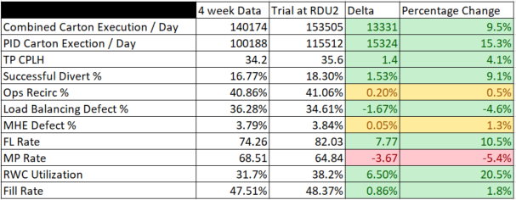
Appendix B: Central Flow TO Allocation Execution Decision Tree in Policy
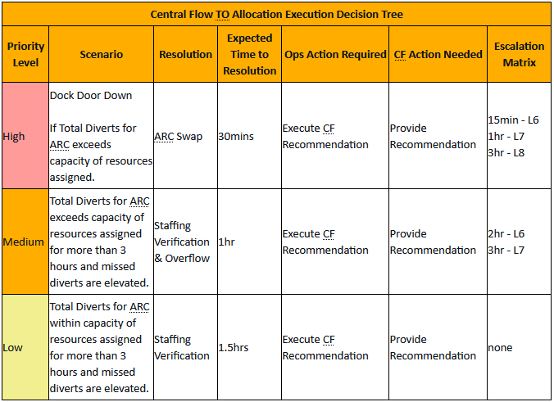

Appendix C: Decision flow for addressing utilization with Lane Availability Tool
